2020

Arora, Ankit

Capgemini

10/8/2020

Car Accident Severity Analysis

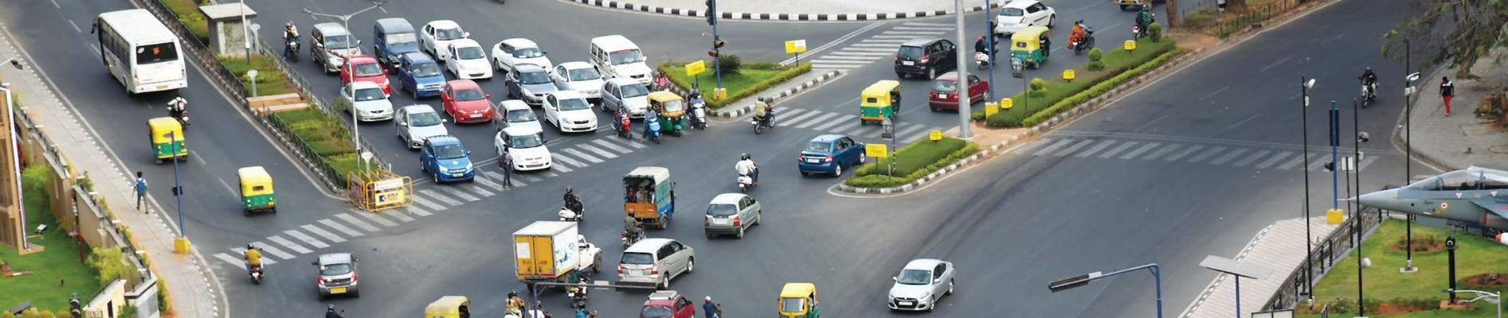

**Contents**

**CAR ACCIDENT SEVERITY DETECTION** 2

**Introduction** 2

**Data Collection** 2

**Methodology** 3

# **CAR ACCIDENT SEVERITY DETECTION**

## **Introduction**

In a recent report it was stated that every 8th causality in the world is happening over the road i.e. 1.35 million people die every year in road accidents. The stats are worrisome in developing countries whereas one can see a negative slope of these kind of incidents in developed countries. There are various factors such as environmental, demographical or violation of traffic norms and in our study we will focus on determining the severity of these traffic accidents based on the type of vehicle, speed, direction, location and other attributes. This solution will help in real-time for critical cases and also for other medical aids determination. We can also help the ambulance service to determine which of the nearest hospital is equipped to take these emergency cases based on the severity of accident and the treatment availability to save lives for specific kind of traumas. Thus, in total, we will help government to track road accidents and to prevent by taking measurements on it. Secondly, for healthcare industry, accident severity will help to make an estimate on injury and then can be recommended to a particular hospital nearby. Third, we can also help insurance agencies to be informed on the kind of accident and the damage cost associated with it.

## **Data Collection**

In order to accomplish the analytics task, we need to gather and process huge amount of data related to car accidents. We have targeted Las Vegas for our analysis and have collected the data for year 2016 of on-road accidents from DataWorld and this is provided by Authorities of Vegas for Open Source Research. The data consist of reason of the accident, crash severity, crash type, longitude and latitude, weather condition, fatalities, people injured, injury type, vehicles involved in clash, area etc.

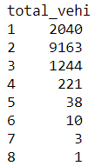

*Fig. 1: Count of accidents with total no. of vehicles*

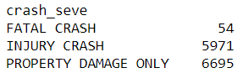

*Fig. 2: Count of accidents with crash severity*

## **Methodology**

Methodology is the process that shows the approach followed to define and solve a business problem. In the introduction section, we have defined the business problem, then in data collection we have provided the reference of data we have taken for Las Vegas. We will be creating Jupyter notebook for interactive data analysis using Python programming language. We will be using Bivariate and Multivariate Linear Regression algorithms for explanatory data analysis and to find relation between independent and dependent variable. Mean Square Error and Root Mean Square Error will help determine the accuracy of our model. But before that we need to focus on Data Pre-processing and Feature Engineering which includes finding and removing outliers, filling up with NULL or missing values, Feature generation,